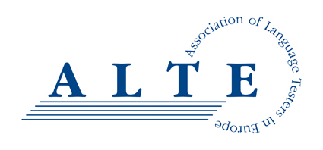
Risk Management Policy

Risk is an everyday part of charitable activity and managing it effectively is essential if the trustees are to achieve their key objectives and safeguard their charity’s funds and assets.
ALTE is not required by law to make a risk management statement in the annual report as it is classed as a smaller charity. Nevertheless, ALTE still acknowledges that the charity trustees have responsibility for risk management in ALTE.
Trustees will identify risks by considering the following (not an exhaustive list):
- the charity’s objectives, mission and strategy
- the nature and scale of the charity’s activities
- the outcomes that need or want to be achieved
- external factors that might affect the charity such as legislation and regulation
- the charity’s reputation with its major funders and supporters
- past mistakes and problems that the charity has faced
- its operating structure
- comparison with other charities working in the same area or of similar size
Trustees will identify risks in a number of areas, including (not an exhaustive list):
- governance
- operational risk
- financial risk
- environmental and external risk
- law and regulation compliance risk
Trustees will assess risk using an appropriate framework to determine a) the severity of the potential risk and b) the likelihood of the potential risk.
Where major risks are identified, trustees will take appropriate action to manage or mitigate for them, either by lessening the likelihood of the event occurring, or lessening its impact if it does. The following are examples of possible actions (not an exhaustive list):
- ending the activity
- transferring to a third party
- sharing the activity with others
- lessening the exposure of ALTE to the activity
- establishing or improving control procedures
- insuring against the risk
- accepting the risk as unlikely and/or of low impact
ALTE’s trustees will periodically monitor, assess and review their assessment of risks. Where appropriate, trustees will use a Risk Register as a tool to aid this process.

ALTE (Association of Language Testers in Europe) is a Charitable Incorporated Organisation, registered in England, Charity number 1184799.

